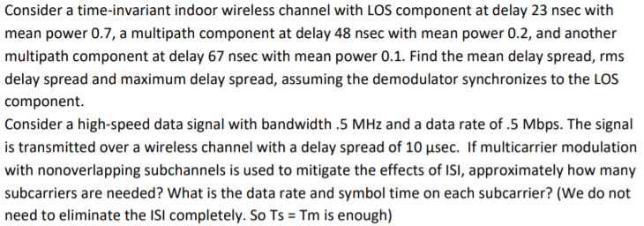

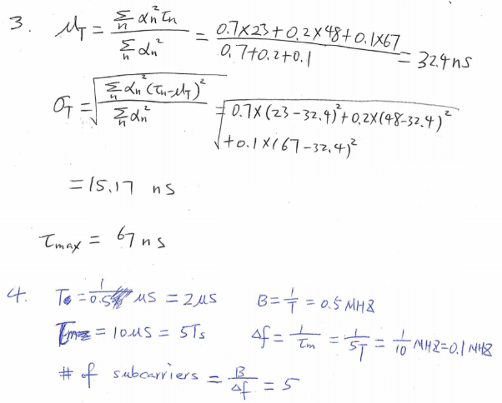

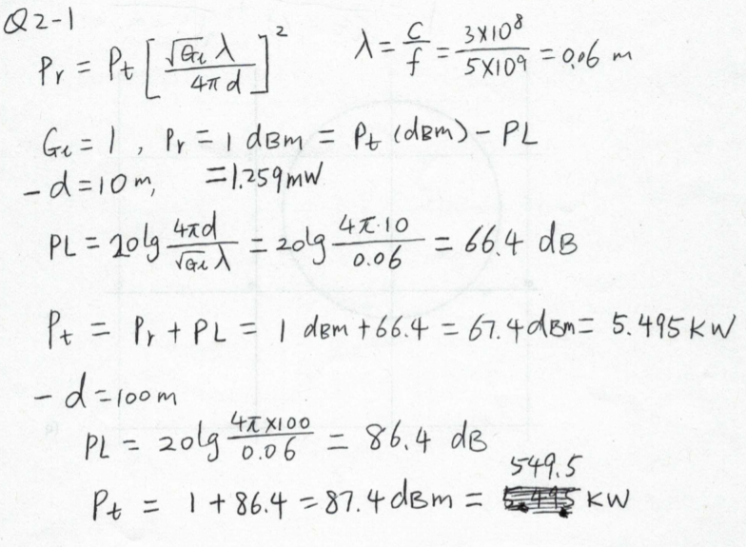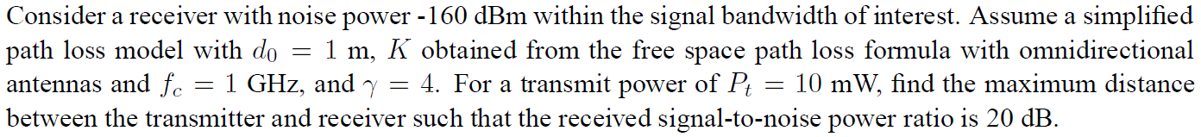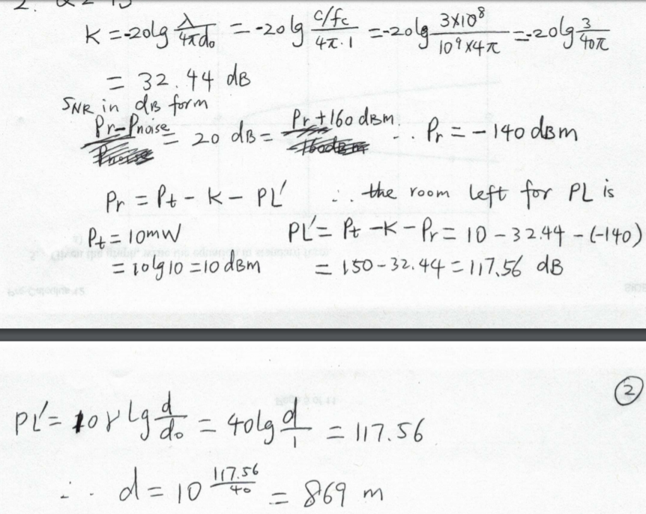

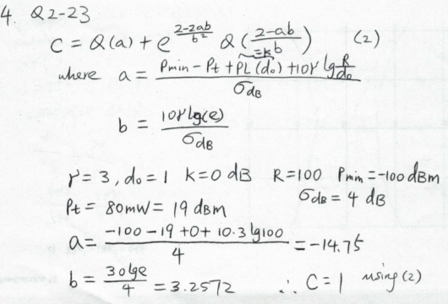C:\Users\dumingyu\AppData\Local\Microsoft\Windows\INetCache\Content.Word\1_3.png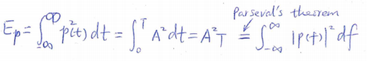

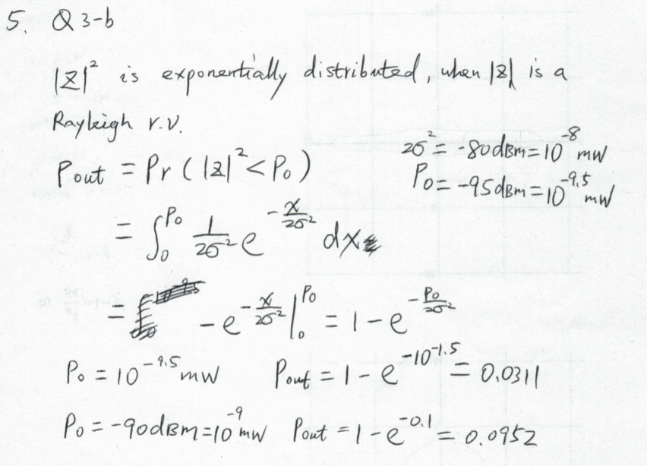

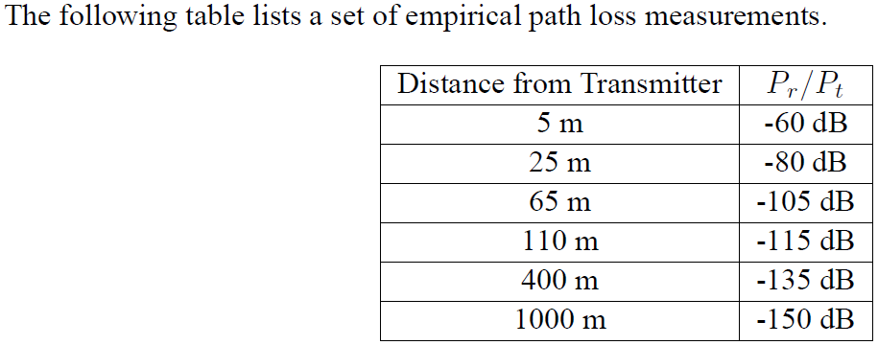

Find the parameters of a simplified path loss model plus log normal shadowing that best fit this data. Find the path loss at 2 Km based on this model.Find the outage probability at a distance d assuming the received power at d due to path loss alone is 10 dB above the required power for nonoutage.

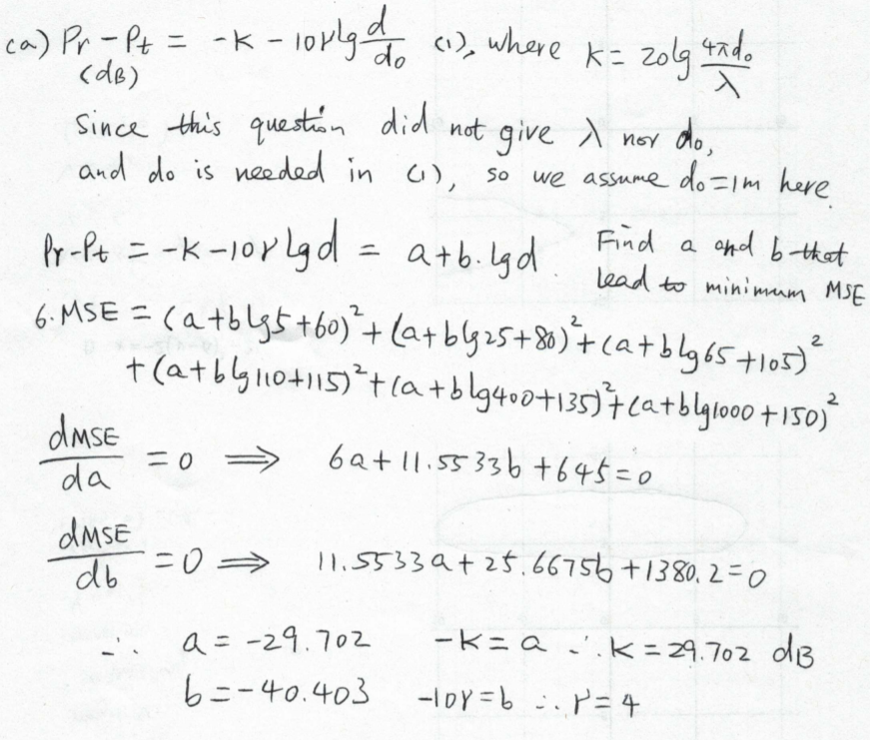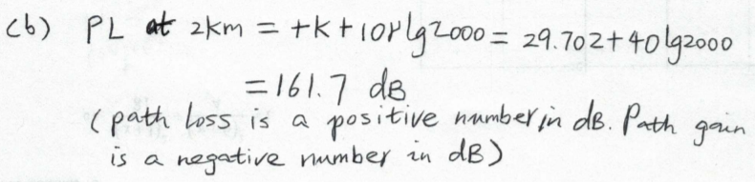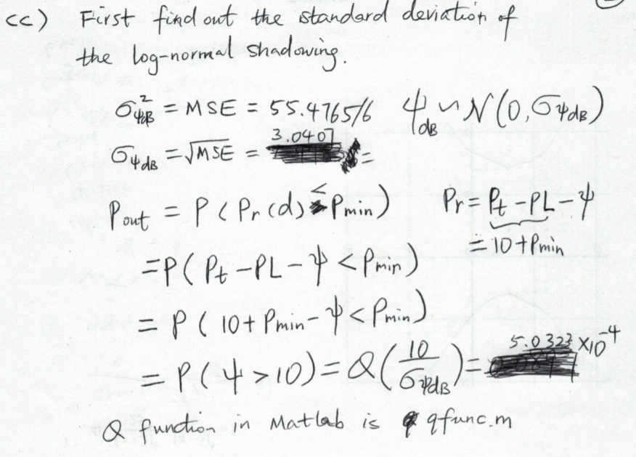

C:\Users\dumingyu\AppData\Local\Microsoft\Windows\INetCache\Content.Word\fourier tansfrom question.png